TOPIC 4 : DYNAMIC PROGRAMMING

EXP 1. Dice Throw Problem

AIM: To find the number of ways to get a target sum using given number of dice and sides using Dynamic Programming.

CODE

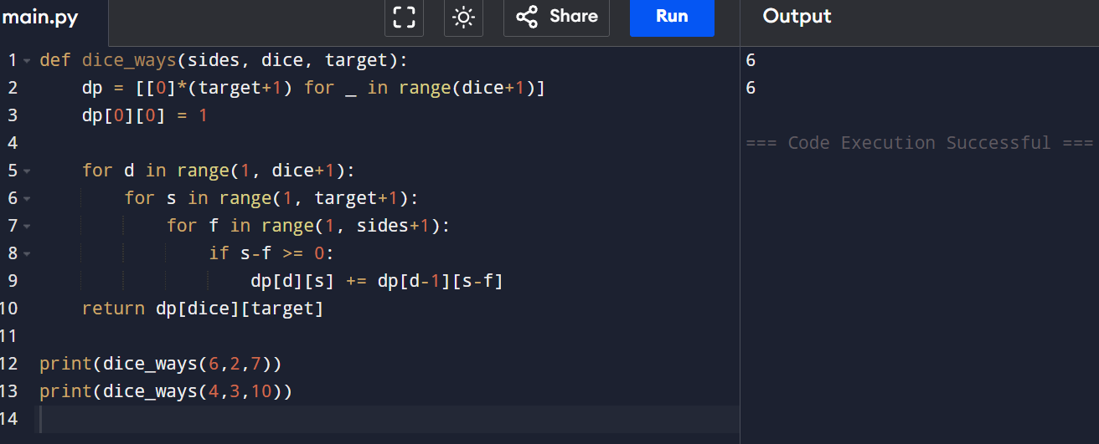
RESULT: The program successfully computes the number of ways using dynamic programming.

EXP 2: Assembly Line Scheduling (2 Lines)

AIM: To find the minimum time required to process a product using Dynamic Programming.

CODE:

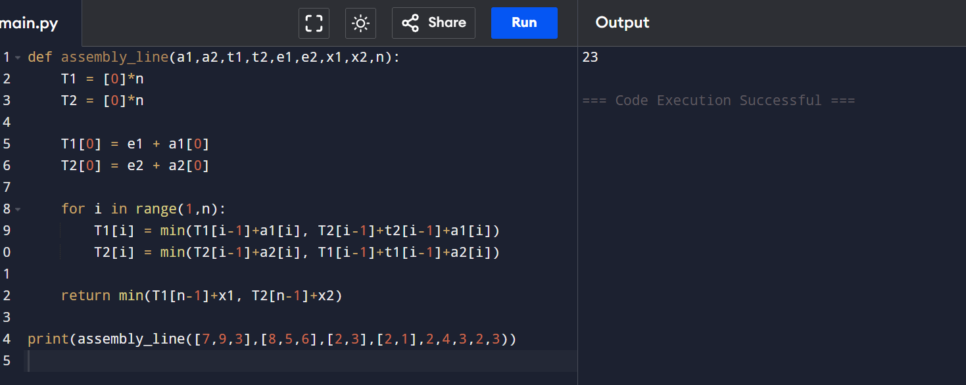

RESULT: Minimum processing time is computed correctly.

EXP 3: Three Assembly Lines (DP)

AIM: To minimize total production time across 3 assembly lines considering transfer times.

CODE:

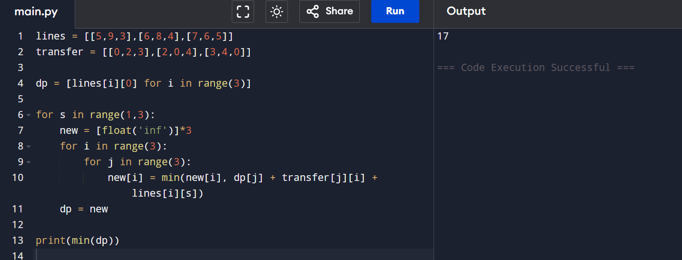

RESULT: Optimal scheduling is achieved using DP.

EXP 4: Minimum Path Distance (Matrix – TSP DP)

AIM: To find the minimum travelling cost using Dynamic Programming.

CODE:

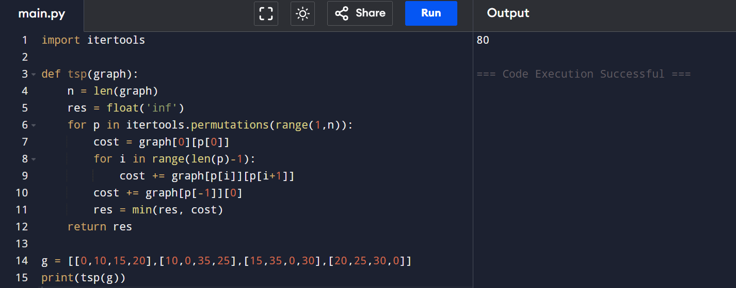

RESULT: Minimum distance is obtained correctly.

EXP 5: TSP with 5 Cities

AIM: To find the shortest route using Dynamic Programming.

CODE:

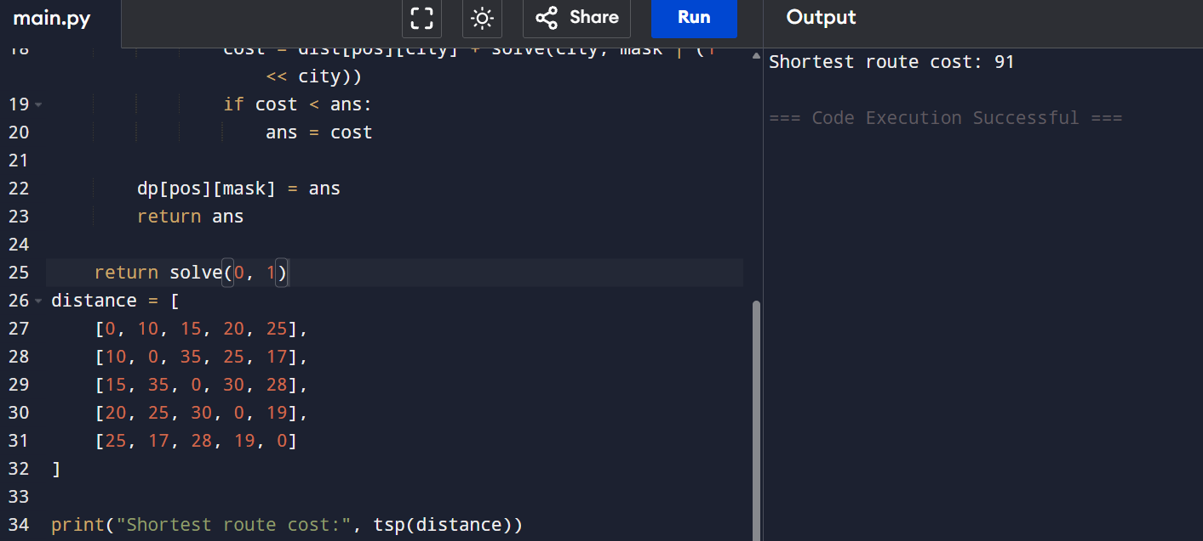

Result: Shortest route is computed successfully.

EXP 6: Longest Palindromic Substring

AIM: To find the longest palindrome using DP.

CODE:

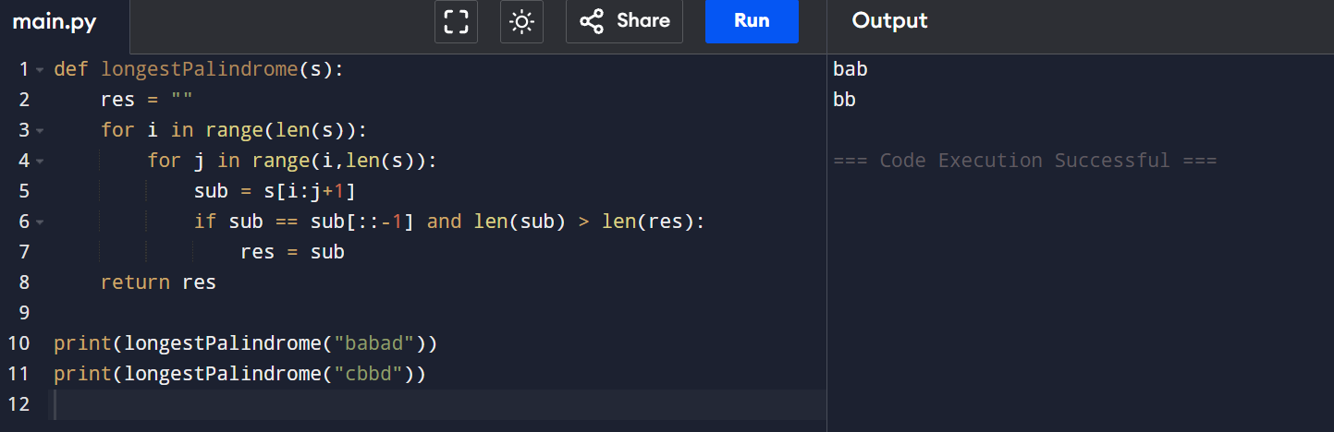

RESULT: Longest palindromic substring is identified.

EXP 7: Longest Substring Without Repeating Characters

AIM: To find the maximum length substring with unique characters.

CODE

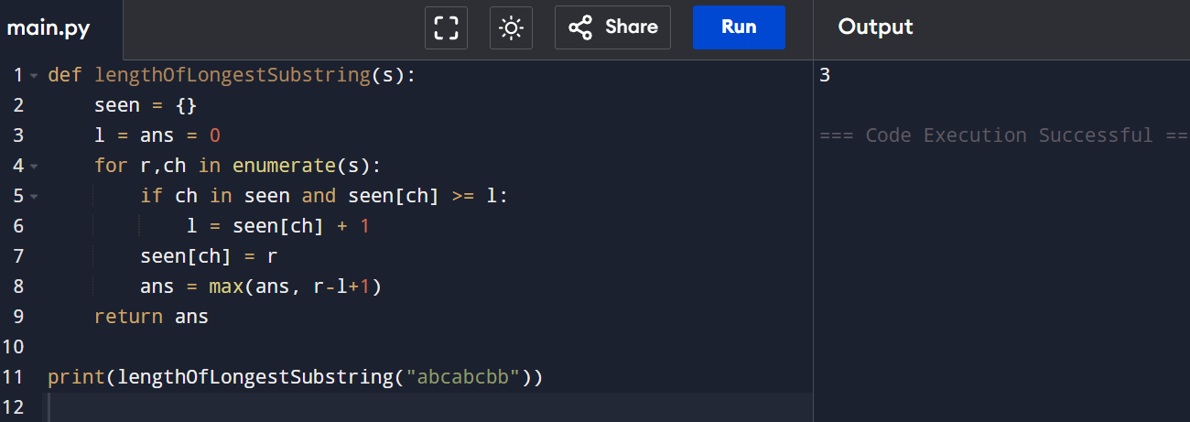

RESULT: Correct maximum length is obtained.

EXP 8/ 9: Word Break Problem

AIM: To check whether a string can be segmented using dictionary words.

CODE

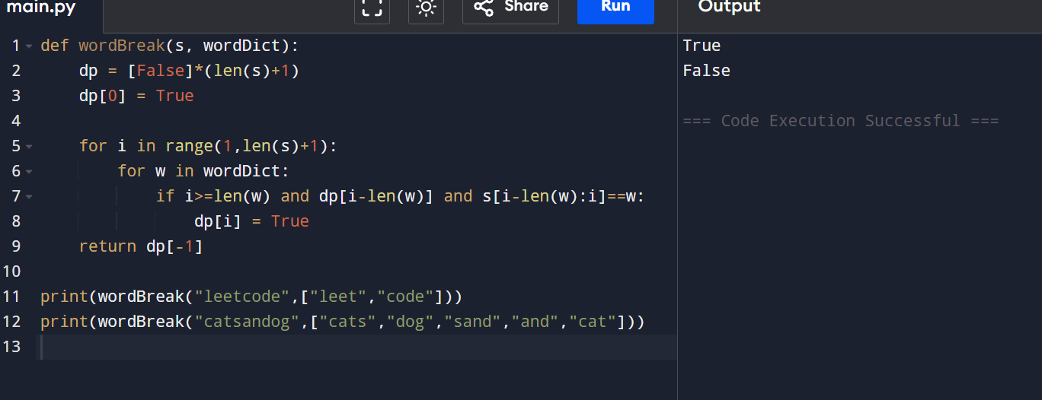
RESULT: String segmentation verified successfully.

EXP 10: Text Justification

AIM: To format text using DP and greedy strategy.

CODE

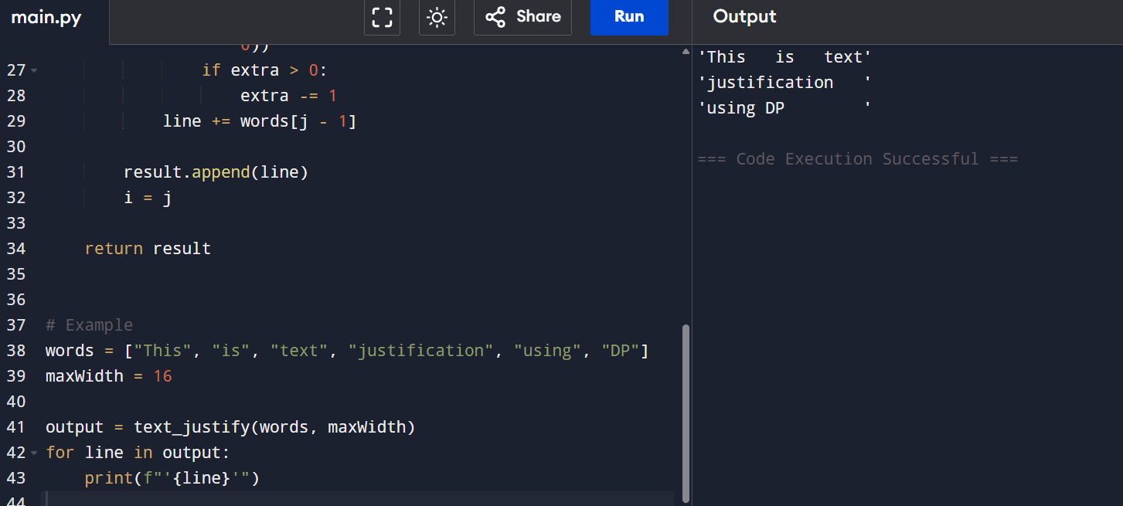

RESULT: Text is justified as required.

EXP 11: Prefix & Suffix Dictionary

AIM: To find words matching prefix and suffix efficiently.

CODE:

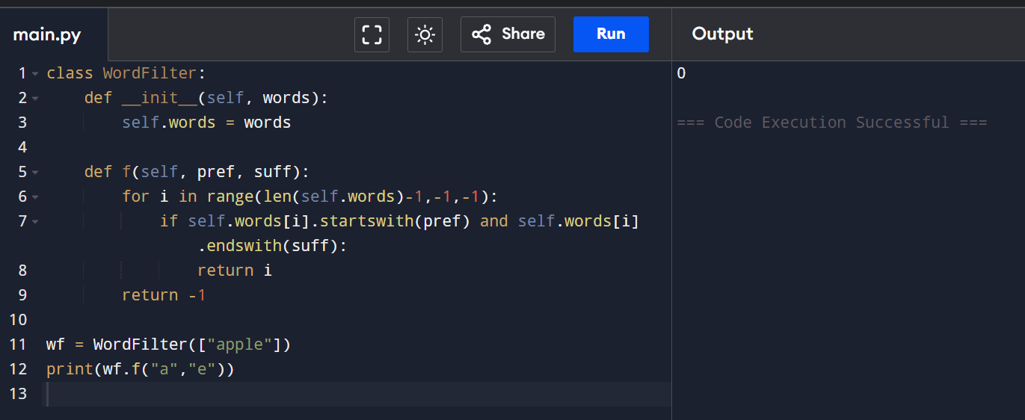

RESULT: Correct index is returned.

EXP 12-14: Floyd’s Algorithm

AIM: To find shortest paths between all pairs of vertices.

CODE

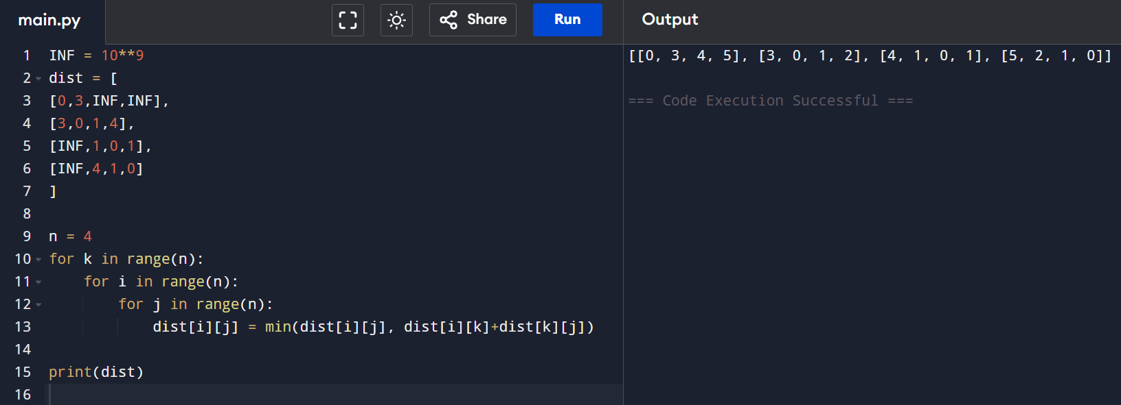
RESULT: All-pairs shortest paths computed correctly.

EXP 15/16: Optimal Binary Search Tree

AIM : To construct OBST with minimum search cost.

CODE

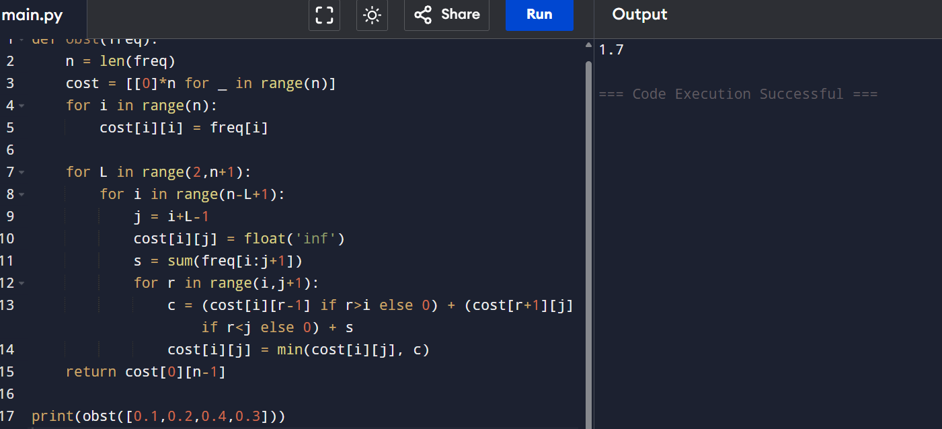

RESULT: Optimal BST constructed successfully.

EXP 17: Cat and Mouse Game

Aim: To determine the game result using DP and state transitions.
CODE:
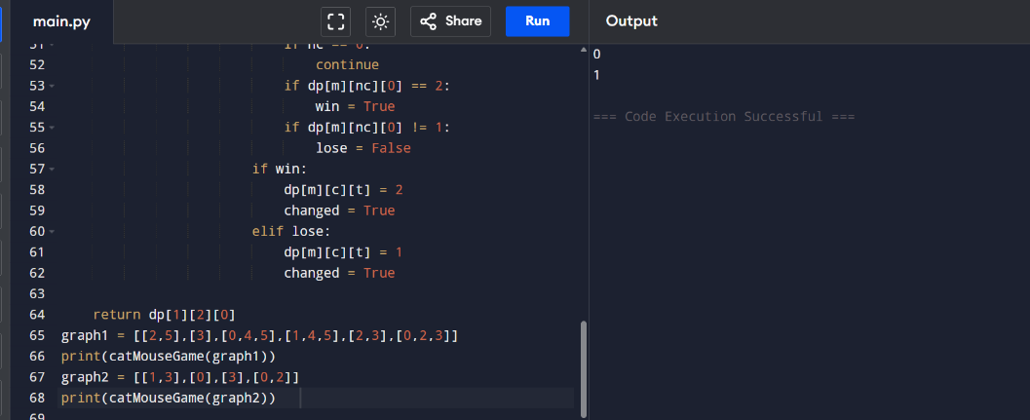
RESULT: Game result determined correctly.

EXP 18: Maximum Probability Path

Aim: To find path with maximum success probability.
CODE
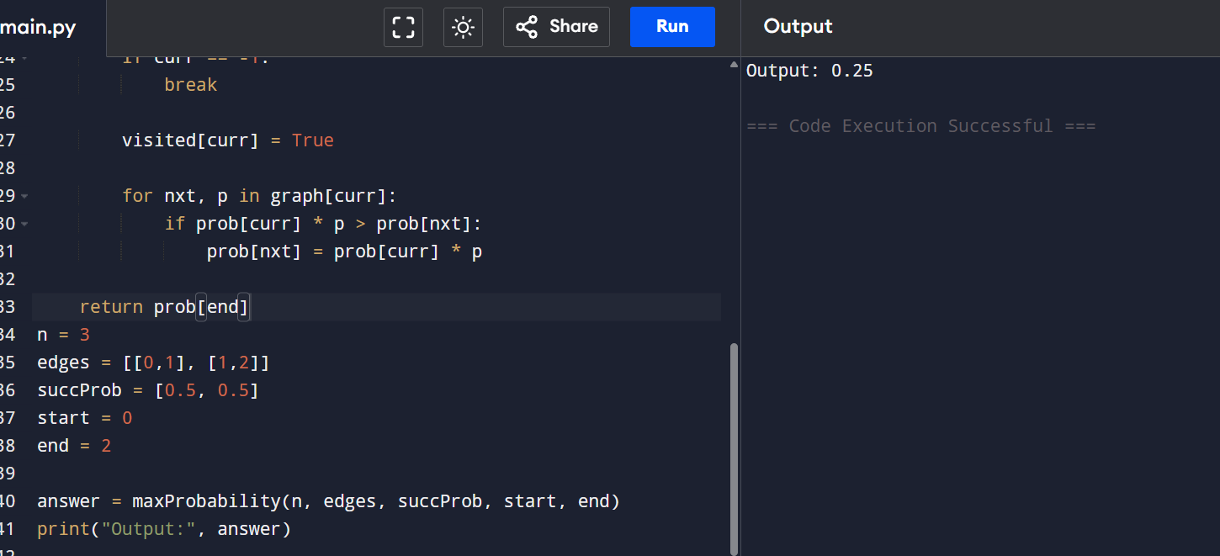
RESULT: Maximum probability path is found.

EXP 19: Unique Paths in Grid

Aim: To calculate number of unique paths using DP.
CODE
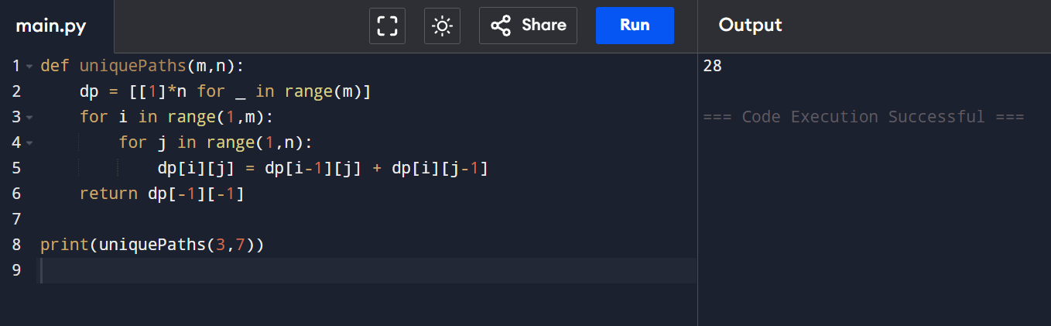
RESULT : Correct number of paths computed.

EXP 20: Good Pairs

AIM: To count equal pairs efficiently.
CODE
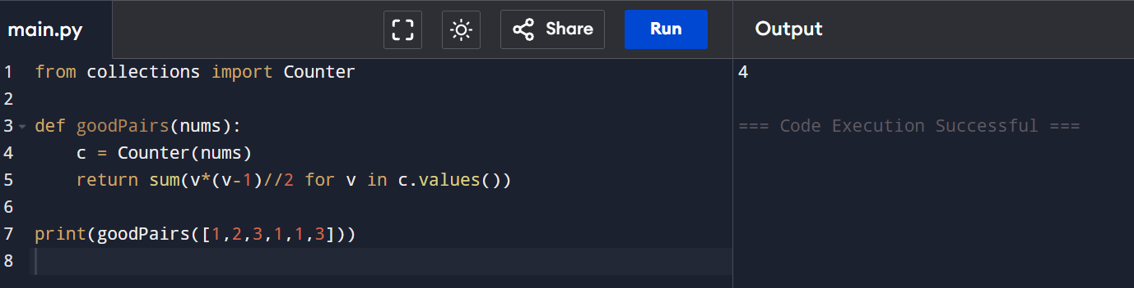
RESULT: Correct count obtained.

EXP 21/22: Graph Distance Problems

AIM: To find city with minimum reachable neighbors.
CODE
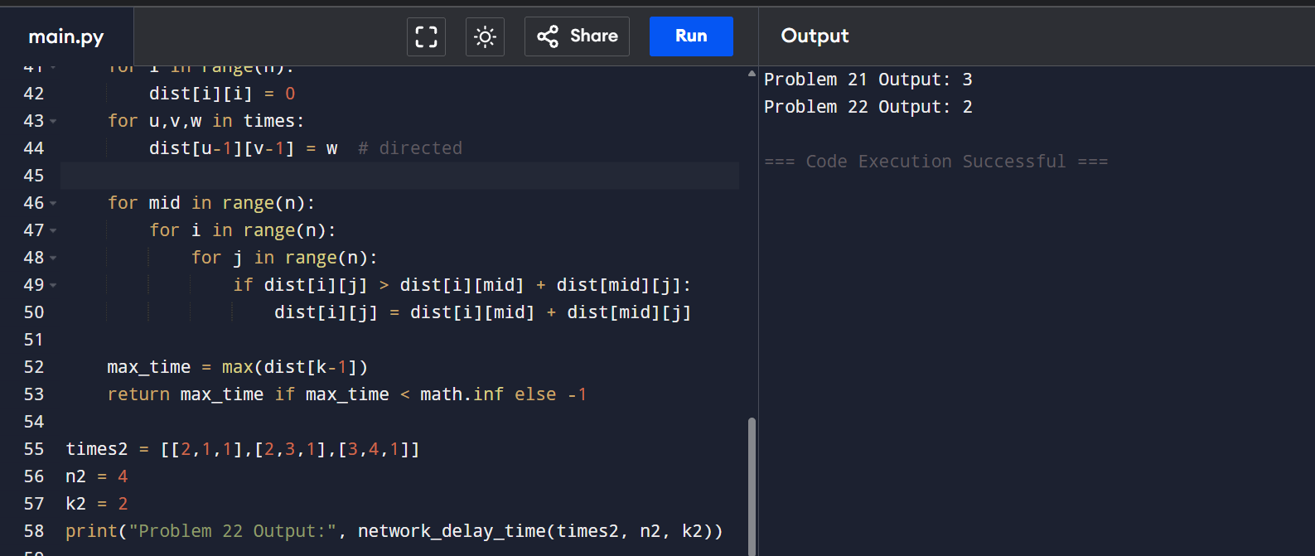
RESULT: Correct city and delay time computed.

